Show Port

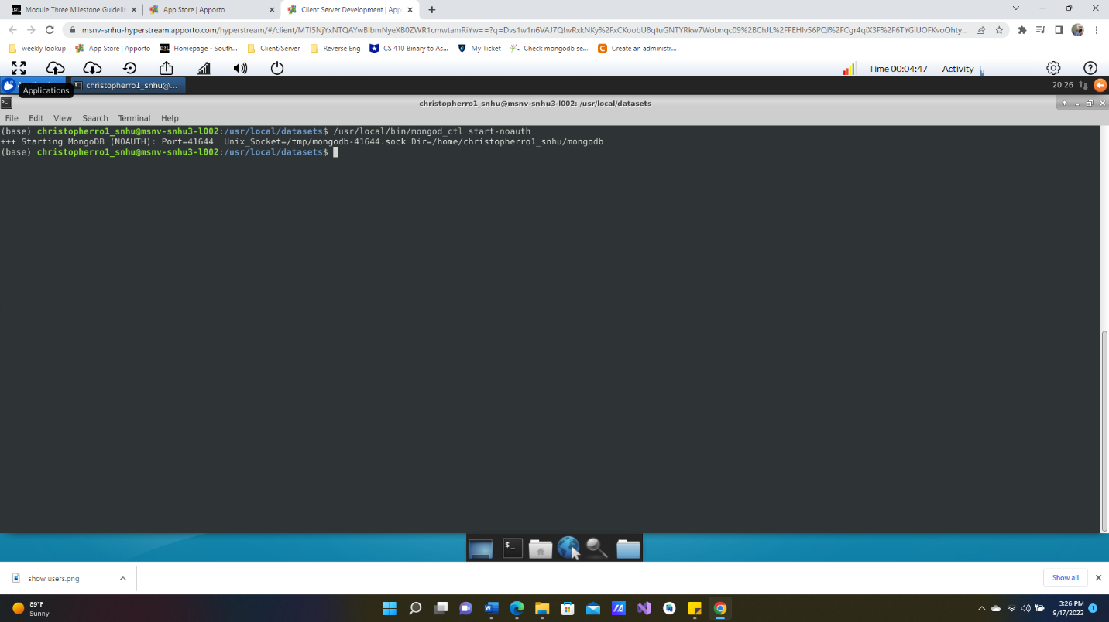

Show Import

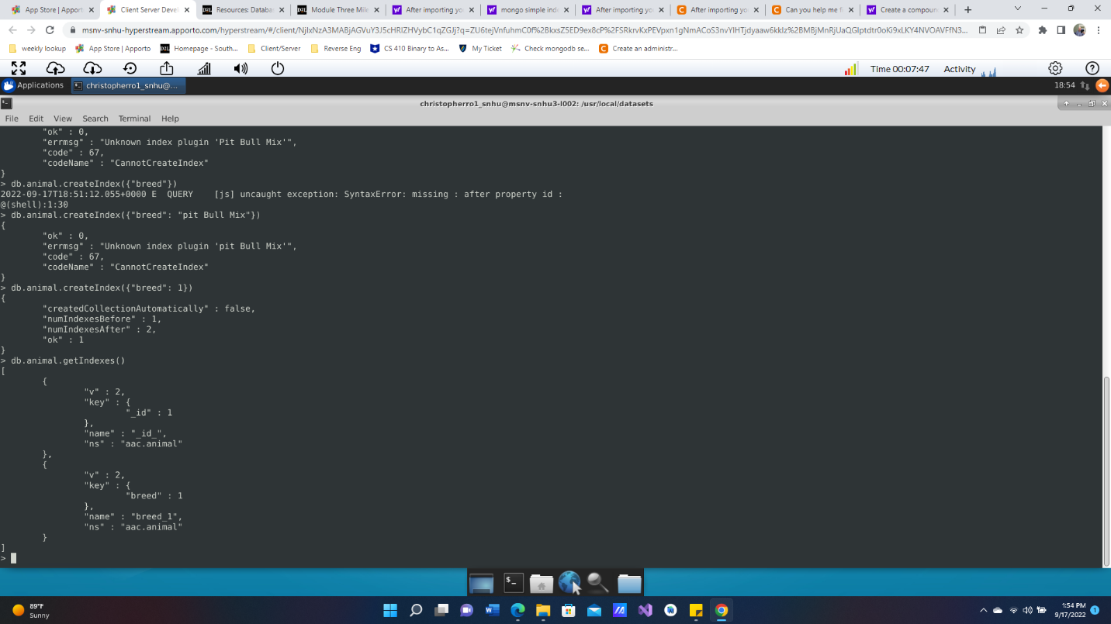

Create Compound index- “outcome_type” of “Transfer”

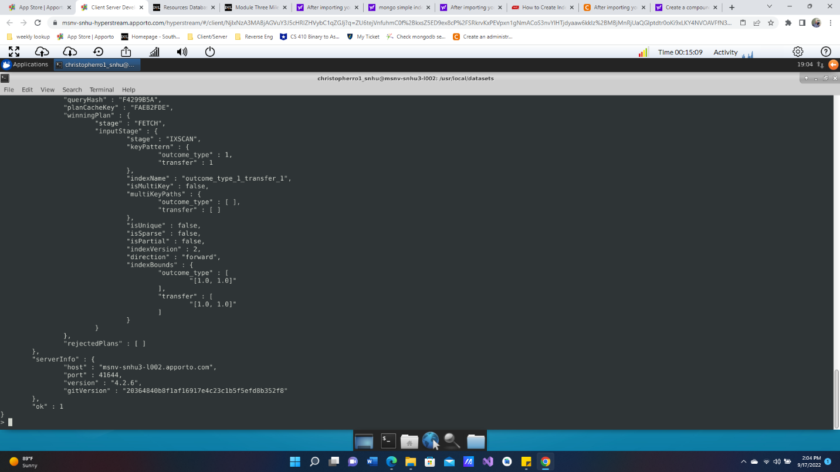

PT 2

Create Admin account(no screenshot) – write down password and username in other location

Authenticate

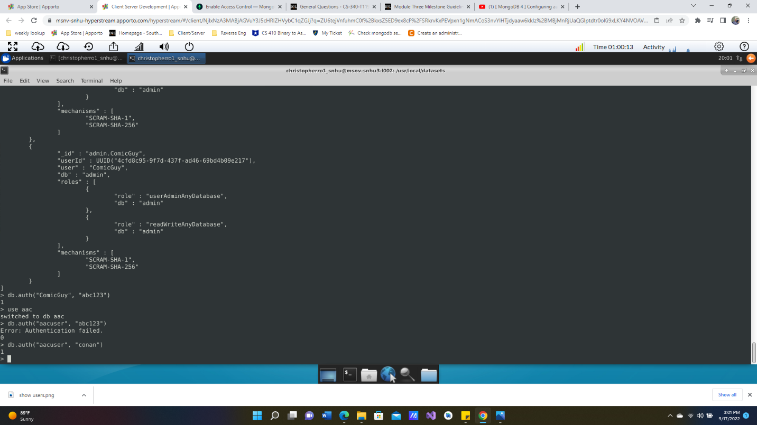

Accuser & Authenticate accuser



Show Login

